Week 1

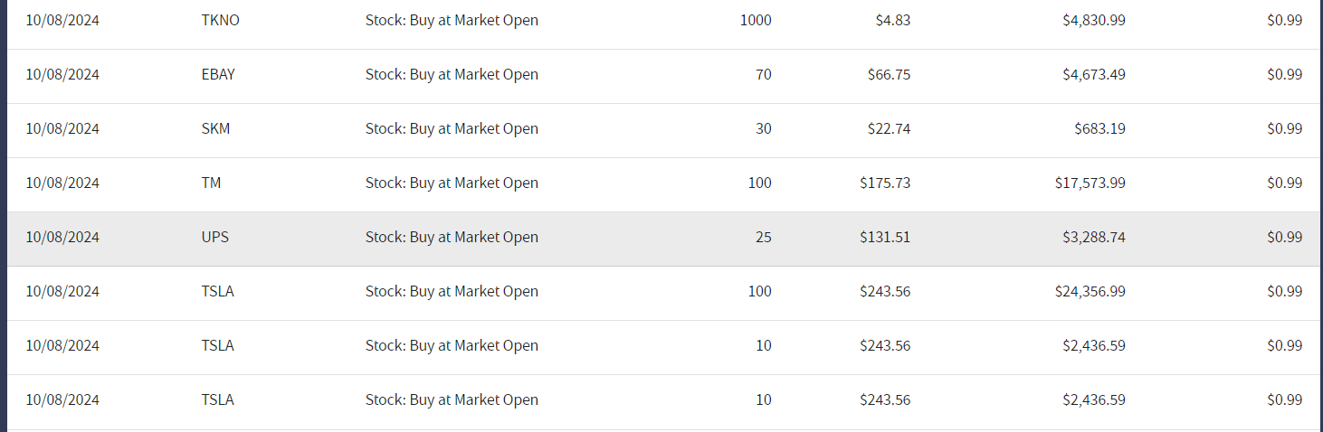

First I invested around 60K$ in all high-tech companies in America most of them were Tesla stocks because Tesla is one of the top 10 companies in the US. I wanted not to focus on only one industry so I also invested 20K$ in UPS and eBay. After 1 day of holding those stocks increased slightly giving me 600$ in annual return profit just in the first 24h, after I sold all of them again tomorrow.

After that trading, I had 100,600$ in cash.



After I got comfortable with trading and made a small profit I wanted to invest all 100K$ in one secure company. So looking at the charts that had only a small increase and decrease through months Investing in MasterCard banking company in the industry of financing was a great choice in my mind. So I went all in it! When I woke up in the morning I saw that the stock market had increased also master card stock was increased which gave me an annual profit of +1100$. For me was a great profit just 3 days in trading I was already +1700$ in profit so I said Thursday I would just see the market and keep the cash.



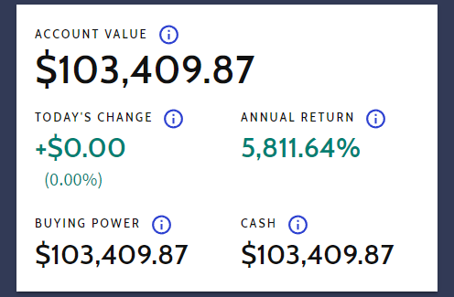On Friday I wanted a fast profit so I just searched for the most hyperactive charge in the day, and I found the ALI BABA company chart as a great opportunity to make a small daily trade, so I went all in again with 100k$. After just 4h my assumption was right and I gained an extra +2100$ profit from Ali Baba.

In my first week, I only dealt with profit which made me fall in love with the stimulator. The final portfolio look like this: